 

# Placement Empowerment Program

***Cloud Computing and DevOps Centre***

Set Up a Virtual Machine in the Cloud Create a freetier AWS account. Launch a virtual machine and SSH into

it.

Name: Harivignesh S

Department: ADS



# Introduction :

This Proof of Concept (PoC) aims to demonstrate the process of deploying a virtual machine in the cloud using the AWS Free Tier. Virtual machines (VMs) play a vital role in cloud computing, allowing users to access scalable computing resources without the need for physical hardware. Through this PoC, you will gain a fundamental understanding of cloud infrastructure and learn how to use AWS EC2 to set up an efficient and cost-effective virtual environment.

# Overview:

1. **Set up a free AWS account** to access cloud resources.

2. **Deploy a virtual machine** using AWS EC2.

3. **Secure the instance** by configuring a key pair and security group settings.

4. **Establish an SSH connection** to the VM from a Windows system.

# Step-by-Step Overview Step

Step 1:

Go to Aws Management console and login using username and password

Step 2:

Open the AWS Management Console and search for **EC2**.

Step 3:

Click **Launch Instances**.

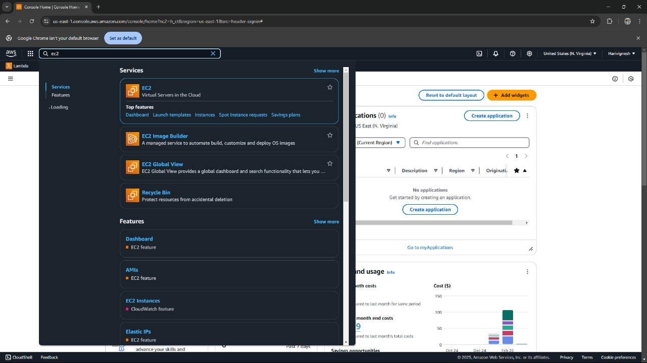

Step 4:

Choose **Ubuntu Free Tier AMI**.

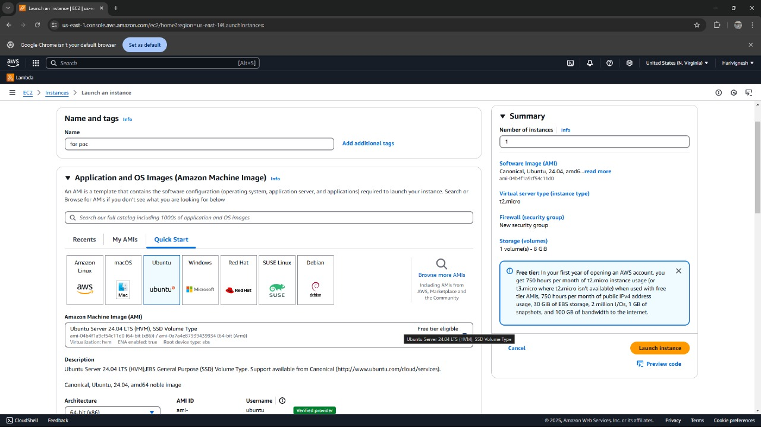

1. Select the **t2.micro** instance type (free tier).

1. Configure security group:

Allow **SSH** (Port 22) from your IP.

1. Add a key pair:

Create a new key pair and download it as a .pem file.

1. Click **Launch Instance**.

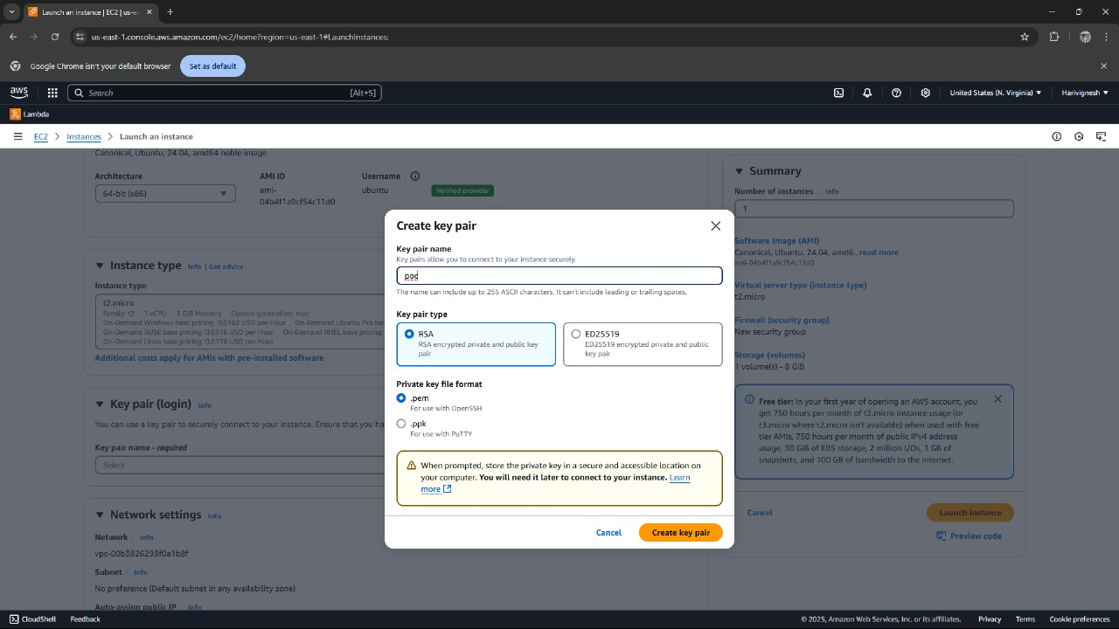

Step 5:

**Successfully** created an instance

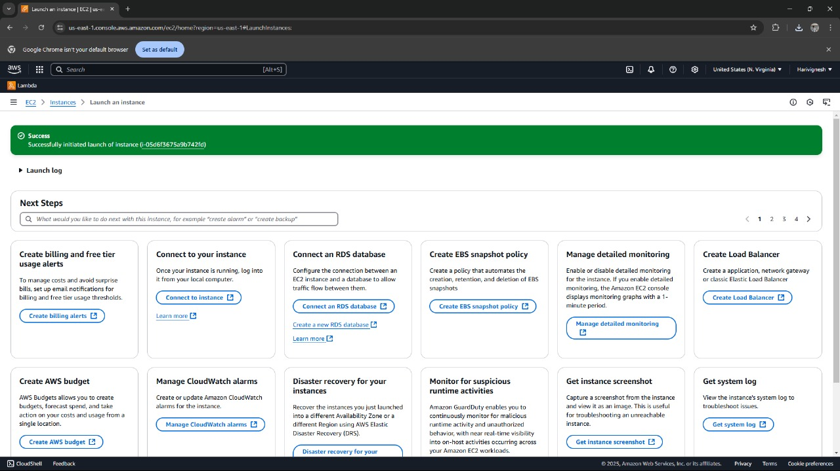

Step 6:

Let’s connect ucing EC2 instance connect

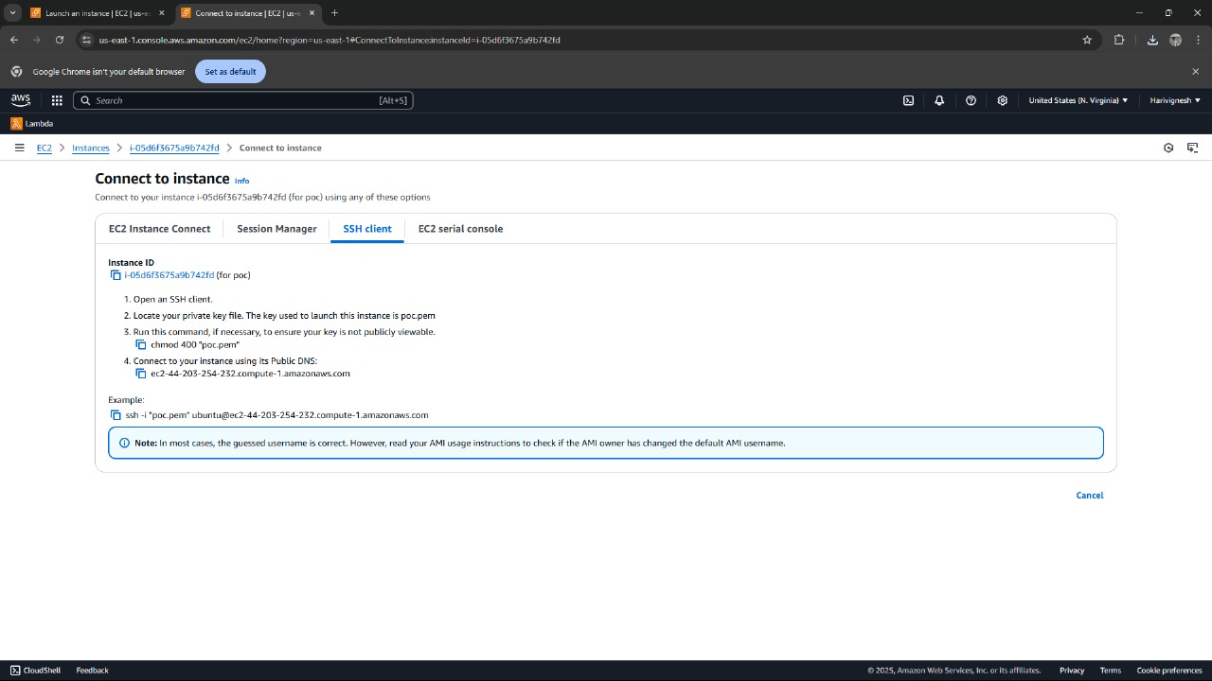

Step 7:

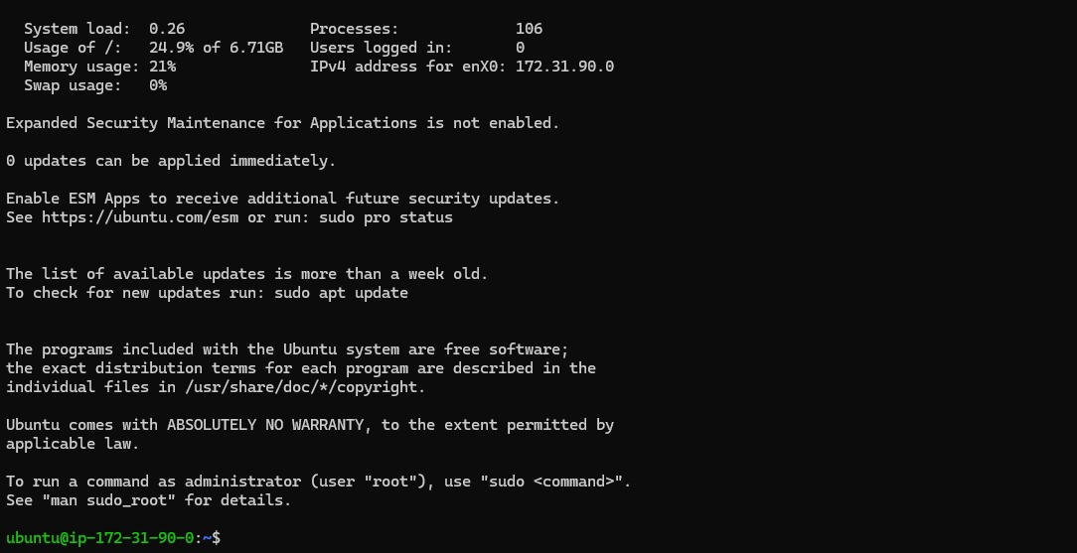

**Successfully completed the setup of a virtual machine in AWS.**

# Outcome :

1. **Set up a free AWS account** to access cloud resources within the Free Tier.
2. **Launch an EC2 instance** running Amazon Linux or Ubuntu as the operating system.
3. **Create and manage an SSH key pair** to securely access your EC2 instance.
4. **Configure security group settings** to allow SSH access from your IP address.
5. **Establish an SSH connection** to the EC2 instance using its public IP.
6. **Develop hands-on experience** with AWS EC2 and fundamental cloud computing principles.